**Team Project Closing-Agile**

**Submission Date/Time:**

* Presentation Due In-Class: **Mon 12/4 & Wed 12/6**
* Project Documents Due in Blackboard: **EOD 11:59PM, Fri 12/8**

**Objective:** To perform closing of the information technology team project that mirrors the real-world

**Product Guidelines:** The final product should include (but not limited to) the following components:

* GUI, Web, or System interface
* Create Read Update Delete (CRUD) Database functions
* Data Analytics feature (Ex. Report, or Dashboard)
* Security feature (Ex. Login, Data Masking, or Encryption)

**Written Deliverable Guidelines: (100 Max Points)**

* Complete all project documents **(Appendices A - H)** in Microsoft Word
* Name the MS Word file: **Team Name_Closing**
* Attach all Meeting Minutes
* Submit all written deliverables in Blackboard Assignment section by the Due Date/Time

**Presentation Guidelines: (30 Max Points)**

* In- class presentation
* Length: 15 minutes including Q&A
* Audience: Key stakeholders
* Delivery: Live presentation, narrated slides, or pre-recorded video
* Format: High-level summary, with built points, tables, diagrams, figures
* Participation: All team members are to present their role and responsible area
* Submission: Submit presentation materials in Blackboard Assignment section
* Peer Review: Complete **Appendix C** **Peer Review** with constructive review of all other projects

**Grading:**

* **130 Maximum Points**
* Team and Individual grading based on the Grading Rubric
* Individual grades also based on Additional Individual Grading Considerations and Self-Peer Evaluation
* Quality Standards: Deliverables should be correct, complete, relevant, consistent, organized, meet guidelines
* Write N/A, Not Applicable, or None for any required section that does not apply to your project. Any section omitted or left blank will be graded as missing.
* Each Missing Guideline Item: Less 5 Points
* Each day late: Less 10 Points
* Grade of Zero after 5 days late

**Grading Rubric**

**Analytic Rubric:** Assess students’ work and their strengths and weaknesses in each area of the BBA Program Learning Goals.

| Criteria (Weight = x1) | Fail  1 | Below Average  2 | Average  3 | Above Average  4 | Outstanding  5 |
| --- | --- | --- | --- | --- | --- |
| Analytical Skills:  Perform Strategic and  Feasibility Analyses  (Max Points = 30) | * Poorly:   + Identifies, explains, analyzes, and shows the relationships between less than half of the strategic and feasibility factors relevant to the organization and the project.   + Analyzes 1 information/method(s) needed to choose among solutions.   + Analyzes 1 alternative solution.   + Determines and justifies that the proposed solution is feasible and addresses all aspects of the problem. * Strategic and Feasibility Analysis had 20 or more quality issues. | * Inadequately:   + Identifies, explains, analyzes, and shows the relationships between less than half of the strategic and feasibility factors relevant to the organization and the project.   + Analyzes 1 information/method(s) needed to choose among solutions.   + Analyzes 1 alternative solution.   + Determines and justifies that the proposed solution is feasible and addresses all aspects of the problem. * Strategic and Feasibility Analysis had 15 - 19 quality issues. | * Adequately:   + Identifies, explains, analyzes, and shows the relationships between half of the strategic and feasibility factors relevant to the organization and the project.   + Analyzes 2 information/method(s) needed to choose among solutions.   + Analyzes 2 alternative solutions.   + Determines and justifies that the proposed solution is feasible and addresses all aspects of the problem. * Strategic and Feasibility Analysis had 10 - 14 quality issues. | * More than adequately:   + Identifies, explains, analyzes, and shows the relationships between most of the strategic and feasibility factors relevant to the organization and the project.   + Analyzes 2 information/method(s) needed to choose among solutions.   + Analyzes 2 alternative solutions.   + Determines and justifies that the proposed solution is feasible and addresses all aspects of the problem. * Strategic and Feasibility Analysis had 5 - 6 quality issues. | * Fully, clearly, consistently, and correctly:   + Identifies, explains, analyzes, and shows the relationships of all the strategic and feasibility factors relevant to the organization and the project.   + Analyzes 3 or more information/method(s) needed to choose among solutions.   + Analyzes 3 or more alternative solutions.   + Determines and justifies that the proposed solution is feasible and addresses all aspects of the problem. * Strategic and Feasibility Analysis had 4 or less quality issues. |
| Technological Skills  (Max Points = 10) | * Far below average technological skills. * Applies appropriate technology correctly in far less than half the instances. * 0 technology approaches identified | * Shows below average technological skills. * Applies appropriate technology correctly in less than half the instances. * 1 technology approaches identified | * Shows average technological skills. * Applies appropriate technology correctly in half the instances. * 2 technology approaches identified | * Shows above average technological skills. * Applies appropriate technology correctly in most instances. * 3 technology approaches identified | * Shows advanced technological skills. * Correct and consistent use of appropriate technology * 4 or more technology approaches identified |
| Civic Awareness and Ethical Decision-Making  (Max Points = 10) | * Displays Little or no knowledge and analytical skills to guide ethical decision-making, and the awareness and responsibilities affecting business. * 1 or 0 factor identified, analyzed, or action recommended. | * Displays insufficient knowledge and analytical skill to guide ethical decision-making, and the awareness and responsibilities affecting business. * 2 factors identified, analyzed, and action recommended. | * Displays average knowledge and analytical skill to guide ethical decision-making, and the awareness and responsibilities affecting business. * 3 factors identified, with 2 or less analyzed, and action recommended. | * Displays very good knowledge and analytical skill to guide ethical decision-making, and the awareness and responsibilities affecting business. * 3 factors identified, analyzed, and action recommended. | * Displays great knowledge and analytical skill to guide ethical decision-making, and the awareness and responsibilities affecting business. * 4 or more factors identified, analyzed, and action recommended. |
| Global Awareness  (Max Points = 10) | * Specifies 0 relevant differences in perspectives and cultures affect business practices globally | * Specifies 1 relevant differences in perspectives and cultures affect business practices globally | * Specifies 2 relevant differences in perspectives and cultures affect business practices globally | * Specifies 3 relevant differences in perspectives and cultures affect business practices globally | * Specifies 4 or more relevant differences in perspectives and cultures affect business practices globally |
| Project Management Discipline  (Max Points = 30) | * Shows little or no Project Management (PM) knowledge and understanding * PM knowledge, skills, tools, and techniques applied far below expectation | * Below average Project Management (PM) knowledge and understanding * PM knowledge, skills, tools, and techniques applied below expectation | * Shows average Project Management (PM) knowledge and understanding * Adequate PM knowledge, skills, tools, and techniques applied meet expectation | * Shows above average Project Management (PM) knowledge and understanding * PM knowledge, skills, tools, and techniques applied above expectation | * Shows advanced Project Management (PM) knowledge and understanding * PM knowledge, skills, tools, and techniques applied far above expectation |
| Written Communication Skills  (Max Points = 10) | * 20 or more writing errors * Written communication, Citation, and/or Integrity Statement far below expectation | * 15-19 writing errors * Written communication, Citation, and/or Integrity Statement is unsatisfactory | * 10-14 writing errors * Written communication, Citation, and Integrity Statement is satisfactory | * 5-9 writing errors * Written communication, Citation, and Integrity Statement meets expectation | * 4 or less writing errors * Written communication, Citation, and Integrity Statement exceeds expectation |
| Oral Communication Skills: (Max Points = 30 Points) | * Little or no oral communication skills * Little or no Presentation Guidelines met * Very poor content, organization, and delivery Presentation 10+ minutes over time * Peer Review poorly completed | * Below average oral communication skills * Presentation Guidelines inadequately met * Inadequate content, organization, and delivery * Presentation 5 to 9 minutes overtime * Peer Review inadequately completed | * Shows average oral communication skills * Presentation Guidelines adequately * Average content, organization, and delivery * Presentation less than 5 minutes overtime * Peer Review is average | * Shows very good oral communication skills * Presentation Guidelines met as expected * Very good content, organization, and delivery * Length meets expectations * Peer Review is above average | * Shows high-level oral communication skills & ability responses to questions * Presentation Guidelines greatly met * Great Content with legible slides * Great organization and delivery * Length is well within allotted time * Great Peer Review |

| 0  No Work  Grade = 0 | 1  Poor  Grade 4 or more below Team Score | 2  Fair  Grade 1 - 3 points below Team Score | 3  Average  Grade = Team Score | 4  Very Good  Grade = 1 - 3 Points above Team score | 5  Excellent  Grade 4 or more points above Team Score |
| --- | --- | --- | --- | --- | --- |
| * Performs no work | * Performance far below expectations * Delivered far below average quality work. * Attended little or no team meetings. * Completed little or no assigned tasks. * Self-Peer Evaluation is 9 Points or less. * OR Workload is 9% or less. | * Performance below expectation * Delivered below average quality work. * Attended less than half the team meetings. * Completed less than half assigned tasks. * Self-Peer Evaluation is between 10-14 Points * OR Workload between 10-14% | * Performance meets expectation. * Delivered average quality work. * Attended about half the team meetings. * Completed half the assigned tasks. * Self-Peer Evaluation is between 15-20 Points * OR Workload between 15-20% | * Performance meets expectation. * Delivered very good quality work. * Attended most team meetings. * Completed most assigned tasks. * Self-Peer Evaluation is between 21-30 Points * AND Workload between 21-30% | * Performance is above expectations. * Delivered excellent quality work. * Attended all group meetings. * Completed all assigned tasks. * Self-Peer Evaluation is 30 Points * AND Workload is above 31% or more. |

**Additional Individual Grading Considerations:** Individual team member scores will be based on the rubric below

**APPENDIX A**

**PROJECT DOCUMENT**

Cuts & Slices:

Project Closing

**CIS 5800 EMWA**

**12/08/23**

**Group 3**

Shaneil Webley-Roberts | shaneil.webleyroberts@baruchmail.cuny.edu

Andy Leon | andy.leon@baruchmail.cuny.edu

Tiffany Tran | tiffany.tran@baruchmail.cuny.edu

Christian Sierra Perez |CHRISTIAN.SIERRAPEREZ1@baruchmail.cuny.edu

Nabil Fayak | nabil.fayak@baruchmail.cuny.edu

Arif Ahmed |arif.ahmed1@baruchmail.cuny.edu

**Table of Contents**

**Executive Summary**….………………………………………………………………………………………………………………………………………………….8

**Project Overview**…………………………………………………………………………………………………………………………….……………………………8

**Appendix B**………………………………………………………………………………………………………………………………….……………………………….9

Awareness Implementation..…………………………………………………………………………………………………….……………………..9

**Appendix C**………………………………………………………………………………………………………………………………………………………………..10

Project/Product/Presentation Peer Review…………………………………………………………………………………………………….10

**Appendix D**……………………………………………………………………………………………………………………………………………………………….12

Product Backlog……………………………………………………………………………………………………………………………………..………12

Sprint Backlog………………………………………………………………………………………………………………………………………..………12

Burndown Chart..…………………………………………………………………………………………………………………………………..………13

Use Case Diagram…………………………………………………………………………………………………………………………………..………14

Sample Code…..……………………………………………………………………………………………………………………………………..………15

Test Scenario & Screen Prints.………………………………………………………………………………………………………………..………16

**Appendix E**………………………………………………..……….……………………………………………………………………………………………………..18

Deployment/Rollout Plan & Product Release……….……………………………………………………………………….………………18

**Appendix F**…………………………….…………………………………………………………………………………………………………………………….…...21

Project Management Plan & Work Plan Updates……………………………………………………………………………………………21

**Appendix G - Project Reporting**…..…………………………………………………………………………………………………………………………...24

**Appendix H - Reference/Integrity/Signatures**…………………………………………………………………………………………………………..26

Citation/Reference………………………………………………………………………………………………………………………….…………….26

Integrity Statement……………………………………………………………………………………………………………………………….………26

Team Members Names and Signatures…………………………………………………………………………………………………………26

**Executive Summary:** *Summarize the content of the written deliverable (1 to 2 paragraph)*

This deliverable is a comprehensive project closing document for our online ordering system for the restaurant Cuts & Slices. It includes a description of the awareness implementation for the new system. It explains our planned action versus our actual action for our project management plan. In addition, there is a product backlog, sprint backlog, a burndown chart, a use case diagram, a network diagram, and sample code for our system. There’s also an update to our WBS inlcuded. This document also includes peer reviews for the other groups’ presentations, status reports to track project progress, progress reports to keep stakeholders informed, a change control log to manage project alterations, an issues log to record and address challenges, and a lesson learned log to foster continuous improvement and knowledge sharing throughout the project's life cycle. Lastly, there's a deployment/rollout plan and requirements for the product's release.

**Project Overview:** *Brief background of the project including overview and current status of the organization.*

Cuts & Slices NYC’s current website lacks the ability to take online orders. Without that feature, the lines at their Queens and Brooklyn locations are super long, making customers wait over an hour to receive their orders. Also, with the customer wait times being so long that may discourage new customers from wanting to place an order. This project’s focus is on implementing an online order management system so that each location can become more efficient and retain more customers.

**Arif APPENDIX B**

**AWARENESS IMPLEMENTATION**

*[Describe/show how any related requirements or business rules for the following areas are implemented in the new system.]*

* *Civic/Ethical/Legal Decision-Making*
* *Global Considerations]*

| Considerations | Planned Action | Actual Action | Outcome | Variance | Comments |
| --- | --- | --- | --- | --- | --- |
| Civic | Some customers may not have access to the internet.  Some people may not understand how to use the online platforms. | Allow the website to be available across multiple device types  Have a frequently asked questions page to answer customer queries | Food can be ordered on desktops and phones  FAQ Page will be made soon. | Plans to add different languages.  Develop a dedicated app in the future. | Need more customer feedback to have FAQ page ready.  Need survey after launch to implement suggestions from users. |
| Ethical | Keeping the customer  data information safe and making sure the data is secured | Have a double authentication method for users.  Encrypt User Data | we decided not to implement a 2FA due to it becoming inconvenient for a customer. | A team to ensure no data breaches occur | Ethics needs to be revisited to ensure compliance with scope |
| Legal | Reviewing the rules and regulations of Delivery food and depending on the state laws | Ensure fair pay and legal regulations are followed by all members and listed on the website | The website currently meets all legal requirements. | We Added sales tax to adhere to state regulations. | It needs to be reviewed consistently to adhere to new regulations. |
| Global | Having a delivery system would require hiring new delivery personnel | The delivery system can create local jobs for NY residents or we can outsource to delivery services such as UberEats, DoorDash, etc. | Our delivery system will create more jobs for people working in apps like DoorDash. | We will work with delivery services to add our restaurant onto their platform as well. | Feedback from delivery customers needs to be reviewed. |

**Arif APPENDIX C**

**PROJECT/PRODUCT/PRESENTATION PEER REVIEW**

Review and rate all other team’s project, product, presentations, project, product using the scale & criteria below.

* Review: Each team is required to provide a constructive review that justifies each rating.
* Rating Scale: 1 = Poor, 2 = Unsatisfactory, 3 = Average, 4 = Good, 5 = Excellent
* Rating Criteria:
  + Project Quality: Project meets project management quality standards and requirements
  + Product Quality: Product meets quality standards and requirements
  + Presentation Quality:
    - Content: Accurate, relevant, consistent, complete, serves purpose and audience.
    - Organization: Content is arranged in a logical order, and flowed smoothly
    - Delivery: Speakers and sound are audible, images, text, video, clear, visible, and understandable
    - Length: Presentation completed within allotted time
    - Subject Matter Proficiency: Presenters show level of understanding and knowledge of subject matter based on correct, appropriate, and timely response to questions

| Team | Feedback | Project Rating | Product Rating | Presentation Rating | Total |
| --- | --- | --- | --- | --- | --- |
|  | -content is very organized and flows smoothly  - pacing of the presentation needs work. | 5 | 5 | 4 | 14 |
|  | -Database and implementation were excellent.  -Content was understandable and their delivery was excellent. | 5 | 5 | 5 | 15 |
|  |  | - | - | - | - |
|  | -Slides were well organized and easy to read.  -Presentation seemed rushed or a bit unprepared | 5 | 4 | 4 | 13 |
|  | -content is very organized and flows smoothly  -The team had a good understanding of the content. | 5 | 5 | 5 | 15 |
|  | -Slides were clean but too simple  -Voices were muffled  - Database needs more work to show specific orders. | 4 | 4 | 4 | 12 |
|  | -Website was very Simple and user friendly.  -Presentation was engaging. | 5 | 5 | 5 | 15 |

**APPENDIX D**

**AGILE/SCRUM PROJECT**

**Agile Artifacts:** *Compete the related agile artifacts.*

**Business Analyst Role assigned to Team Member Name: __________Christian & Andy____________________**

**Product Backlog:** Update final product backlog with any changes

| ID | Item | User Story | Estimate (Days) | Priority | Sprint | Status |
| --- | --- | --- | --- | --- | --- | --- |
| 1 | Menu | As a customer, I can browse the Cuts & Slices website. | 5 | Medium | 1 | Completed |
| 2 | Order Placement | As a customer, I can add menu items to my cart. | 6 | High | 1 | Completed |
| 3 | Authentication | As a customer, I can signup and login to the website. | 3 | High | 3 | Completed |
| 4 | Order Placement | As a customer, I can check out my order for delivery. | 6 | High | 2 | Completed |
| 5 | Admin Dashboard | As a restaurant admin, I can review in progress orders. | 6 | High | 1 | Completed |
| 6 | Order Management | As a restaurant admin, I can update the status of an order. | 4 | Medium | 3 | Completed |

**Sprint Backlog:** Update Sprint Backlog for final sprint(s). Perform the tasks listed in the Sprint Backlog.

Sprint 2 Backlog

| Product Backlog ID | Product Backlog Item | User Story | Task | Task Owner | Estimate (Days) | Actual (Days) | Status |
| --- | --- | --- | --- | --- | --- | --- | --- |
| 4 | Order Placement | As a customer, I can check out my order for delivery. | * Use HTML to create the form and JavaScript to send the form to the database | Andy | 6 | 3 | Completed |

Sprint 3 Backlog

| Product Backlog ID | Product Backlog Item | User Story | Task | Task Owner | Estimate (Days) | Actual (Days) | Status |
| --- | --- | --- | --- | --- | --- | --- | --- |
| 3 | Authentication | As a customer, I can signup and login to the website. | * Use HTML and JavaScript to validate user signup and login | Nabil | 6 | 4 | Completed |
| 6 | Order Management | As a restaurant admin, I can update the status of an order. | Setup the back4app database and connect it to the dashboard page. Use HTML to design the dashboard and JavaScript to handle CRUD operations. | Andy | 4 | 3 | Completed |

* **Burndown Chart:** Graph counting down from total to zero Sprint Backlog items to be completed for final sprints

Sprint 2 Burndown Chart

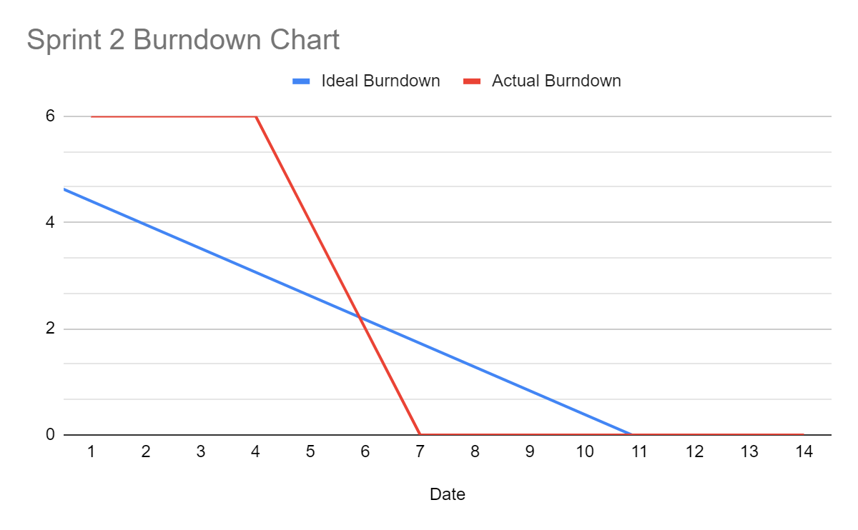

Spring 3 Burndown Chart

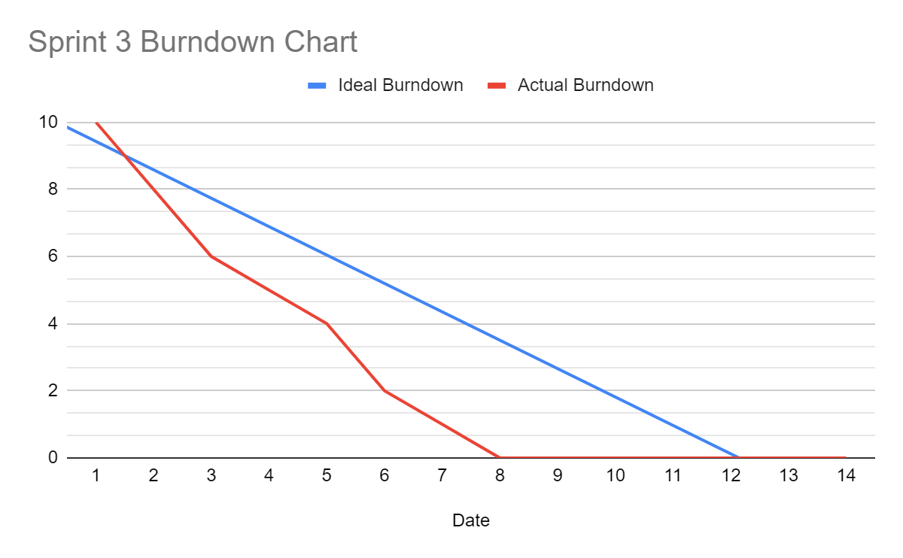

**System Analyst Role assigned to Team Member Name: ____________Shaneil__________________**

* + - Provide one or more design specifications for each completed Sprint Backlog item. The specification could be a UML model/diagram such as a Use Case Diagram or Description, an Activity or Sequence Diagram.

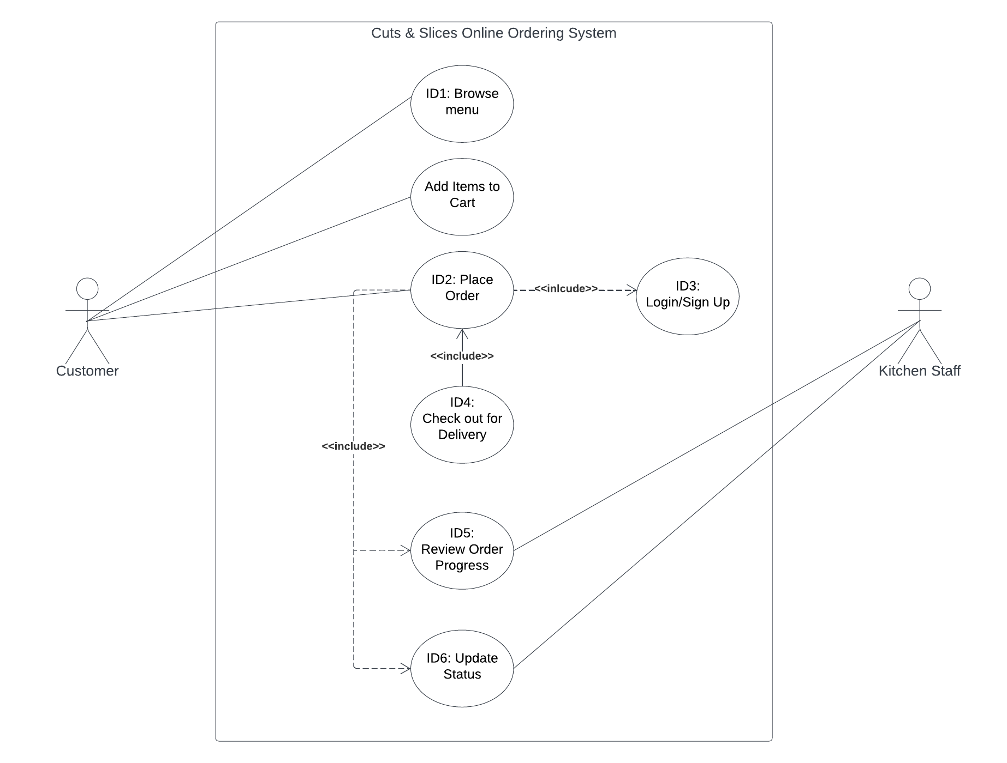

**Programmer Analyst Role assigned to Team Member Name: _________Andy & Nabil_____________________**

* + - Provide a sample of the Source Code for completed Sprint Backlog items.

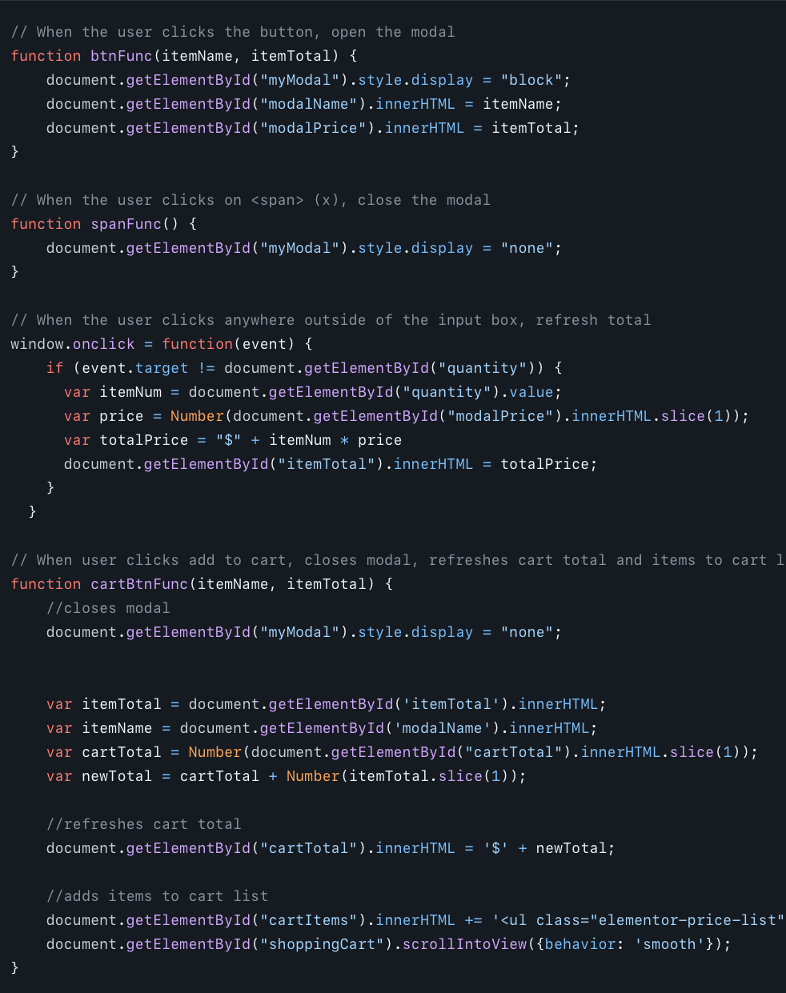

**Quality Management Role assigned to Team Member Name: ________Arif______________________**

* Provide Test Scenario and Screen Prints of tests and results for each completed Sprint Backlog item.

1. Adding Menu Items to Cart

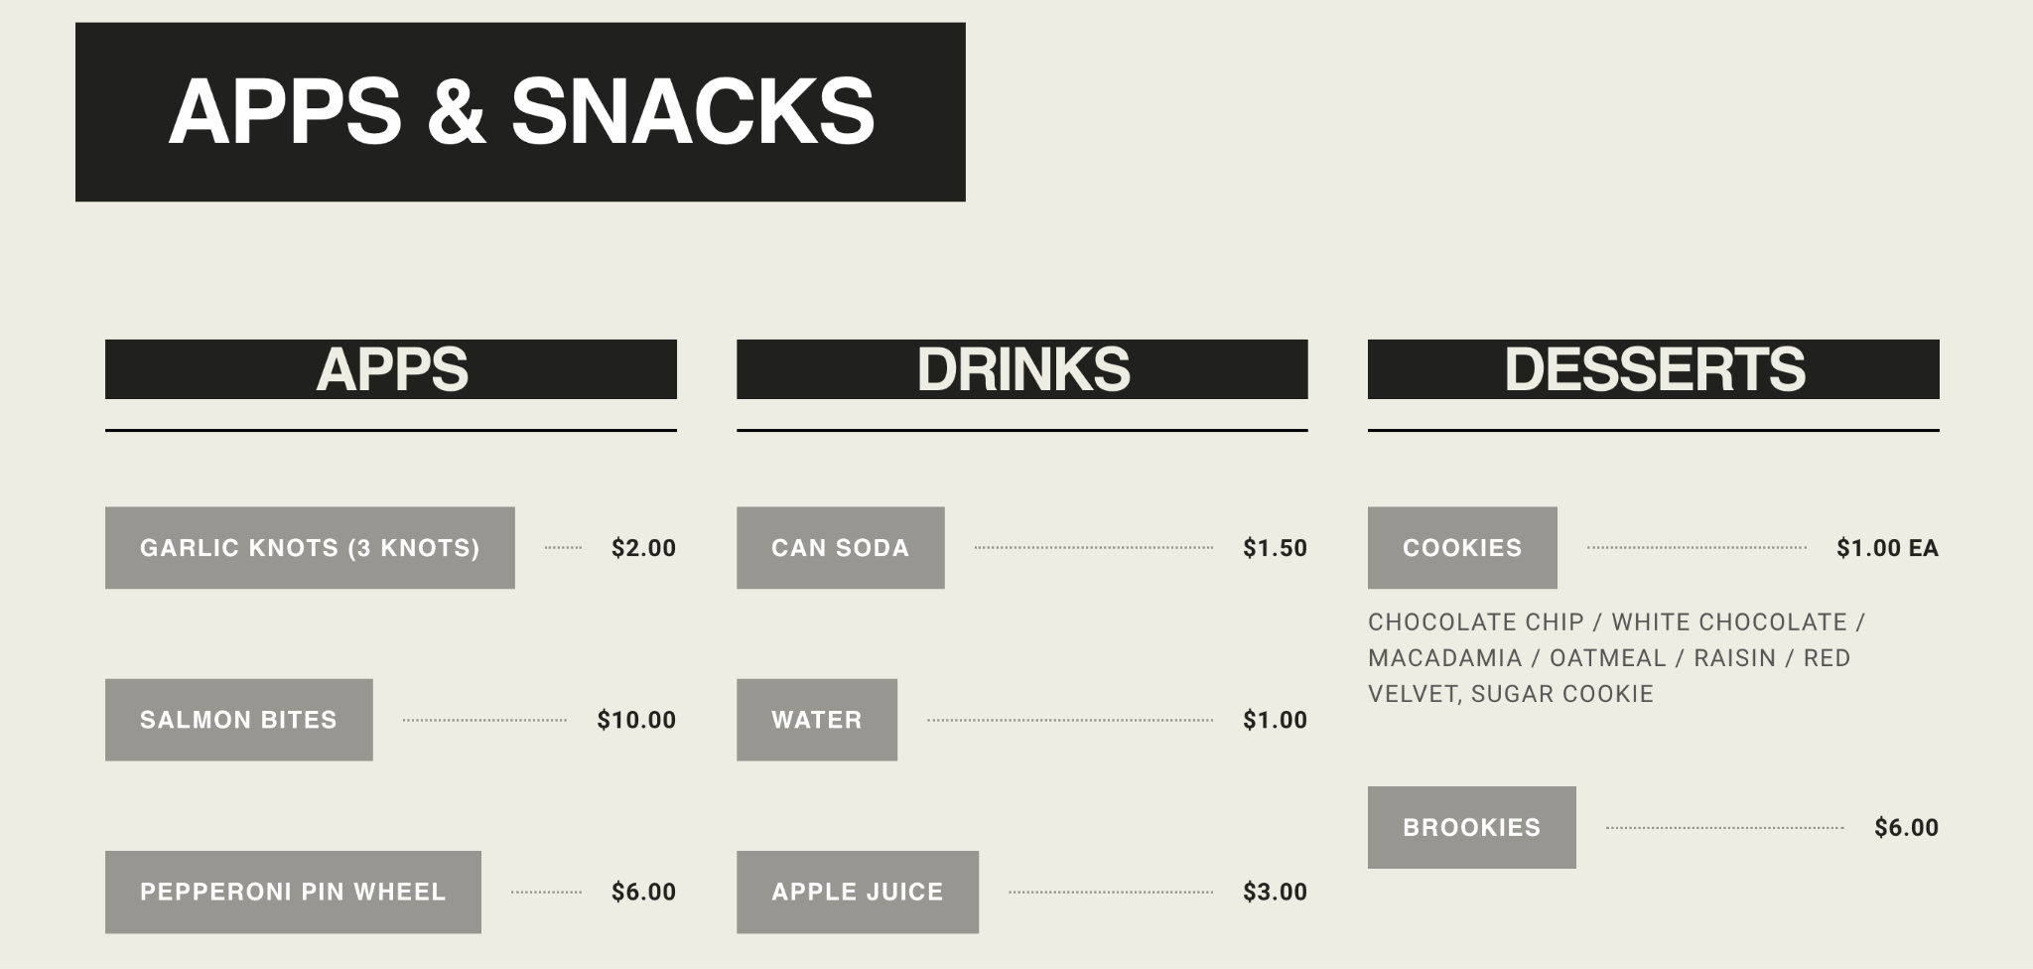

1. Placing Order

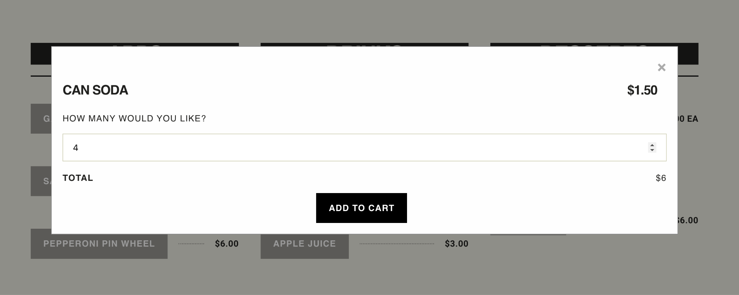

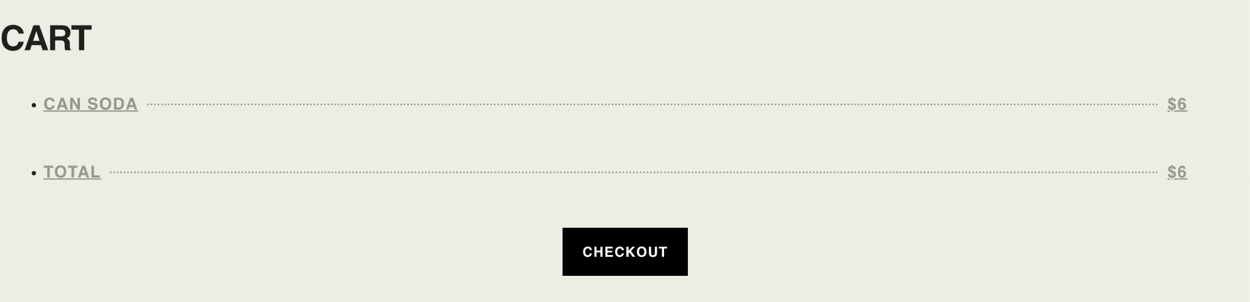

1. Login / Account Creation Page

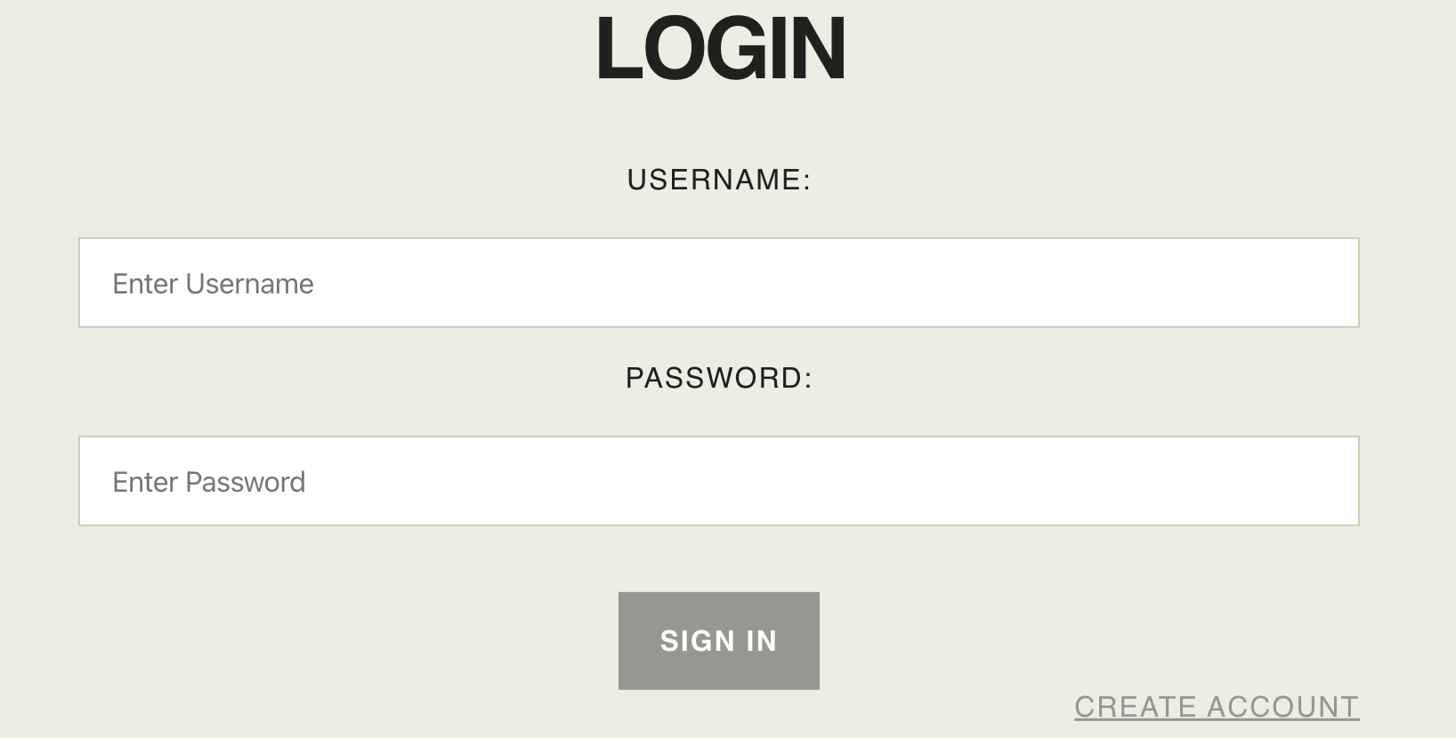

**APPENDIX E**

**Deployment/Rollout Plan & Product Release**

**Business Analyst Role assigned to Team Member Name: _________Christian_____________________**

**Analysis:**

Complete the Rollout Plan below:

**Action Plan:** *List the tasks, schedule, resources, and cost needed to rollout the product.*

| ***Tasks*** | ***Schedule******Days*** | ***Resources*** | ***Costs*** |
| --- | --- | --- | --- |
| Menu | 5 | *PA* | *$2,500* |
| Order Placement | 6 | *PA* | *$2,500* |
| Authentication | 3 | *PA* | *$2,500* |
| Order Placement | 6 | *PA* | *$2,500* |
| Admin Dashboard | 6 | *PA* | *$2,500* |
| Order Management | 4 | *PA* | *$2,500* |

**Communication Plan:** *Describe two or more ways to inform stakeholders of rollout.*

1. Email Updates: keeping updates with stakeholders and providing information to rollout milestones, benefit and support channels to the project.
2. Zoom Meeting: making meeting on each sprints to see what is going with the feedbacks and keeping up to date

**Training Plan:** *Describe two or more types of user training for the rollout.*

1. Onsite Training: to conduct on-site training to each store location, providing each on-site locations with manual and materials
2. Online Training Modules : developing interactive online and making it comfortable for all staff and employees to use.

**Organizational Change:** *Describe two or more organizational (policy or procedural) changes needed.*

1. Policies Update: applying new policy on the website and updating employee guidelines on the website.
2. Customer Relationship Management (CRM) System: A CRM system may act as a central location for all client data, including previous orders, online payments, preferences, communication history, and more. This data can help businesses adjust their interactions with customers and better match their product catalog demands.

**Global/Ethical/Legal/Civic/Social/Environmental Awareness:** *Identify two or more key considerations.*

**Ethical**:

Keeping the customer data and their privary safe

**Issue:**

* Keeping the customer data information safe and making sure the data is secured

**Solutions:**

1. Keeping the Customer Information safe and private
2. Encryption

**Legal:**

**Issue:**

* Reviewing the rules and regulation of Delivery food and depending on the state laws

**Solutions:**

1. Ensure fair pay and legal regulations are followed by all members and listed on website
2. Making sure the delivery worker are protected and safe travel

**Maintenance/Support:** *Propose two or more ways to support and maintain the product.*

1. 24/7 Help Support: there can be chatbox to help with assistance whenever something go wrong and keeping up to date
2. Updates to all Business Information: Most consumers of your website want instant information about your restaurant. It is critical that your business hours, address, phone number, menu, pricing, and any special deals are all current.

**Future Enhancements:** *Proposed two or more key future enhancements.*

1. Real time Ordering Taking: making sure the customer have access to real time whenever there food are ready like a time frame to pick their food
2. Coupons and Discount: Having deals like coupons can help with customer interest in buying more at cheaper prices. Increase sales and quality of the items begin to sell quicker.

**System Analyst Role assigned to Team Member Name: __________Shaneil____________________**

**Technology**

* List all technologies required to release the product to end-users

| Technology | Type | Estimated Cost |
| --- | --- | --- |
| Hosting Service | Software | 1500 |
| Database Server | Software | 2000 |
| Programming Languages | Software | 1000 |
| Order Tracking System | Software | 1500 |

* Create high-level Deployment or Network Diagram of the production technologies

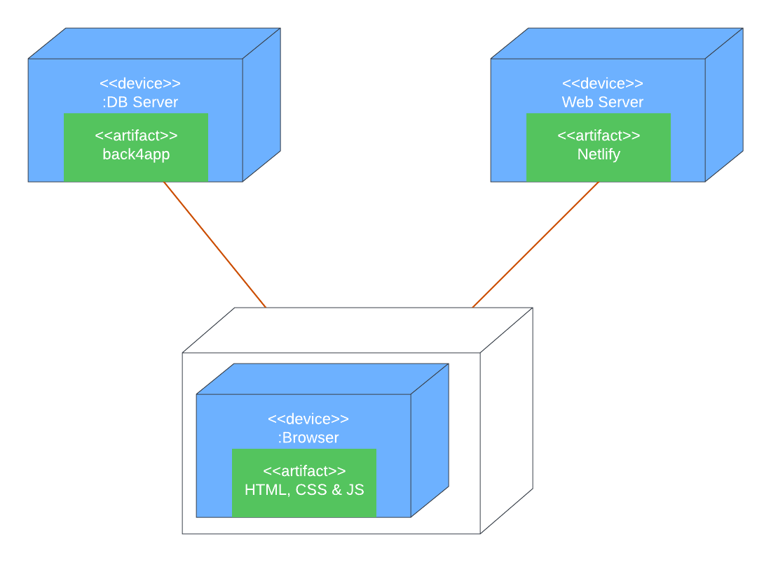

**Programmer Analyst Role assigned to Team Member Name: ____________Andy & Nabil__________________**

* Data Population: *Describe how the system will be populated with data (Data Migration, Data Conversion, Data Entry)*

The product is connected to back4app, a lightweight database. It is connected via an API key. In our product, we wrote code that writes the customer’s order details to the database. This is our CREATE operation. In the restaurant side dashboard, restaurant staff can click the refresh button to query the database to read all orders in the table. This is our READ operation. When orders are submitted, their order status is In Progress. In the dashboard, restaurant staff can click on the In Progress button to switch it to Completed when the order is ready for delivery. This is our UPDATE operation.

* **Product Release:** *Submit final product on standard medium (Link, .EXE file, etc.). Provide all credentials and system configuration to access the product*

<http://tinyurl.com/cuts-slices>

**APPENDIX F**

**PROJECT MANAGEMENT PLAN & WORK PLAN UPDATEs**

**Project Management Plan Update:** *[Update the Project Management Plan showing the planned vs. actual areas:*

| Knowledge Area | Planned Action | Actual Action | Outcome | Variance | Comments |
| --- | --- | --- | --- | --- | --- |
| Quality Mgmt | Use project mgmt software to create and manage user stories/product backlog items | Used Excel to keep track of all product backlog items and user stories | Was able to keep track of progress | Didn’t use a project mgmt software | Using a project mgmt software would’ve given us a much cleaner visual |
| Communication Mgmt | Will use Zoom and WhatsApp for all team meetings and communication | Used Zoom for meetings and WhatsApp for communication | Team was able to stay in contact at all times | No difference | Sometimes there will be late responses to messages in chat. Team started to “@” specific team members for quick response |
| Escalation | Will use majority rules voting system for all issues | Team voted on all project matters | Allowed the team to move on from issues quickly. | No difference | Helped team avoid any conflict |
| Risk Mgmt | * Provide support to team member(s) not proficient in coding * Hold sprint retrospectives * Load testing | * Team members most proficient in coding were the designated programmers   - Held sprint retrospectives | * Saved time by having skilled programmers * Held a meeting at the end of project phase | * Load testing hasn’t been done * Didn’t need to provide any support | Team was able to make fast progress and minimized the chance of future issues with code |
| Procurement Mgmt | * Use IDE for writing code   - Github for the collaborative coding process  - Use back4app for backend | * Used IDE for writing code   - Github for the collaborative coding process  - Used back4app for backend | Coding process went smoothly and team members were able to work collaboratively | No difference | Was successful in implementing the system using these items |

**Christian Work Plan Update:** *[Update the Project Work Plan showing the planned vs. actual areas:]*

* *WBS (Scope Baseline)*
* *Schedule with Duration, Start and Finish Dates (Schedule Baseline)*
* *Resources*
* *Cost with funding limit of $200,000 (Scope Baseline)*

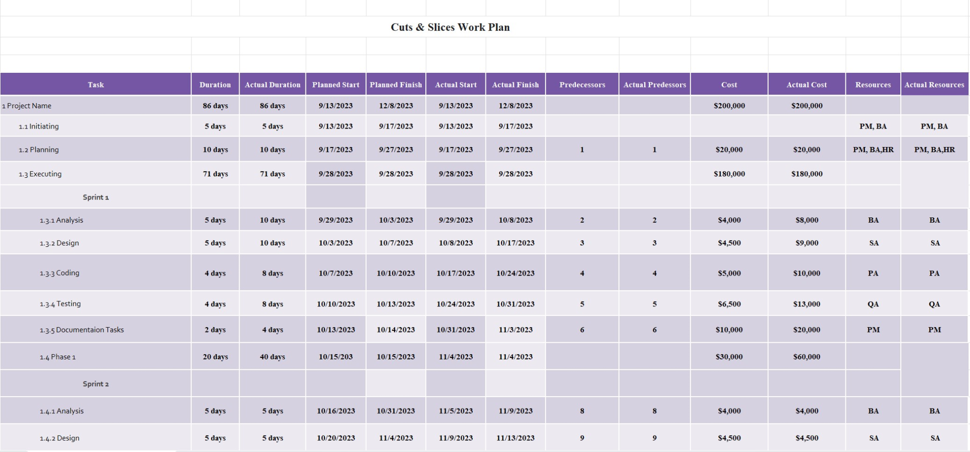

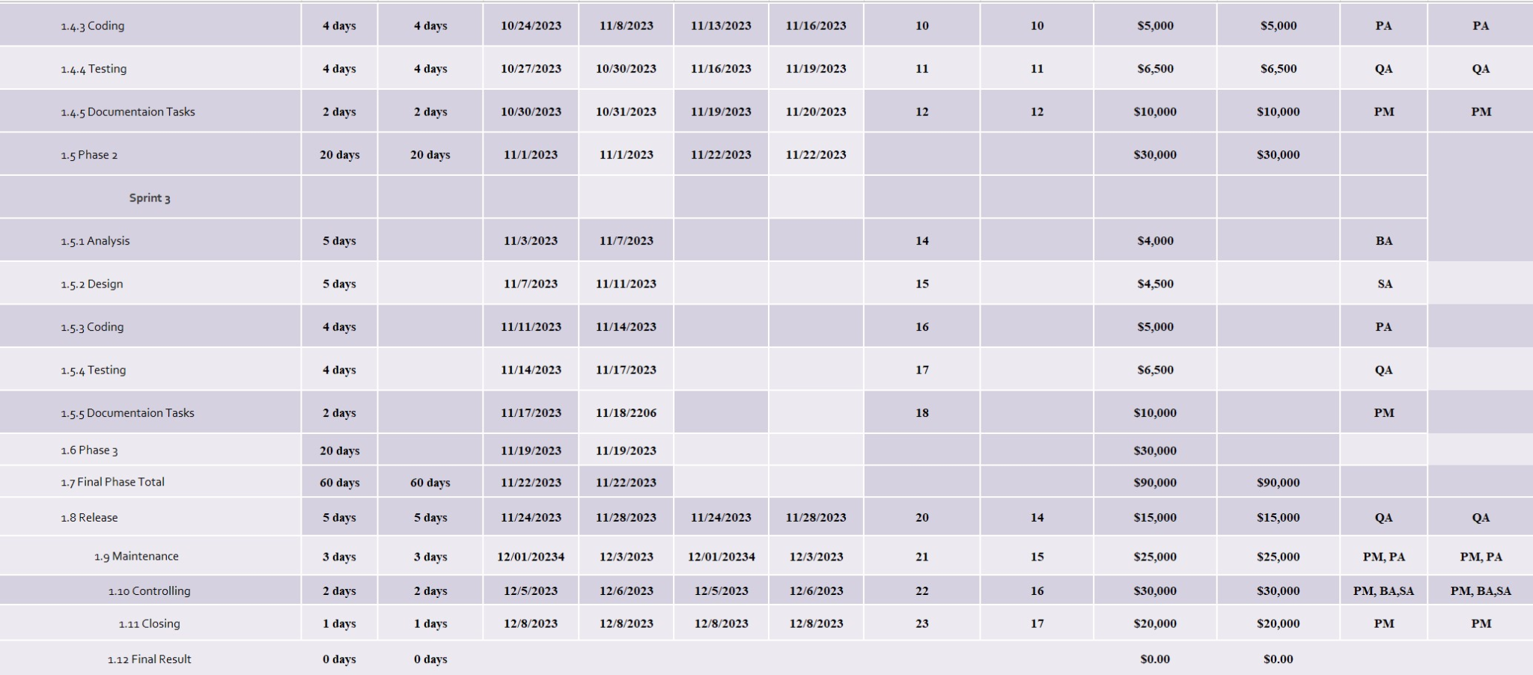

**APPENDIX G**

**PROJECT REPORTING**

**Project Team: ____3___ Project Title: Cuts & Slices Online Ordering System Date Prepared: ___11/05/2023_____**

**Reporting Period Start Date: ___11/18/2023_______ Reporting Period End Date: ___12/08/2023____**

**Status Report**

**Project Status Summary:** *Provide brief overview of how the project is progressing as of the reporting date.*

* The project has been progressing well as of 11/04/2023. We have improved on our communication and had more meetings to keep everyone on the team accountable. Since we are closing up the project we were finishing up on final touches but we are still within scope, schedule, and cost.

**Status:** *Based on variance between the planned and actual performance metrics, or other EVM formulae.*

**Green (On-track)**, **Yellow (At risk)**, **Red (Off-track)**

| Performance Metrics | Status | Notes |
| --- | --- | --- |
| Scope | **Green (On-track)** | We are still within our scope and capable of all the tasks required |
| Schedule | **Yellow (At risk)** | Due to communication, there was a slight delay causing us to be behind, however, we are still on schedule to complete the project on time. |
| Budget | **Green (On-track)** | Still within the budget of $200,000 |

**Progress Report**

Tasks completed this reporting period

| Assigned Team Member | Tasks Completed | Work Plan ID | Baseline Completion Date | Actual Completion Date | No. of Tasks | Workload  % Total Tasks = [(No. of Tasks ÷ Total Tasks)] x 100 |
| --- | --- | --- | --- | --- | --- | --- |
| Nabil | Adding additional features | 5 | 12/01 | 12/03 | 1 | 16.6% |
| Andy | adjusting functionality to demo | 2 | 12/01 | 12/02 | 1 | 16.6% |
| Christian | Adjusting the WBS | 6 | 12/06 | 12/03 | 1 | 16.6% |
| Tiffany | Progress reporting | 4 | 12/06 | 12/04 | 1 | 16.6% |
| Shaneil | Network diagram | 1 | 12/06 | 12/02 | 1 | 16.6% |
| Arif | Quality assurance | 3 | 12/01 | 12/04 | 1 | 16.6% |

Tasks planned for next reporting period

| No. | Tasks to be Completed | Work Plan ID | Assigned Team Member | Planned Start Date | Planned Finish Date |
| --- | --- | --- | --- | --- | --- |
| 1 | adjustments to demo | 7 | Nabil & Andy | 12/07 | 12/11 |
| 2 | quality assurance | 8 | Arif | 12/07 | 12/11 |
| 3 | project performance analysis | 9 | Shaneil | 12/07 | 12/11 |
|  |  |  |  |  |  |

**Change Control Log:** *Indicate any major change planned and/or completed during the reporting period.*

| Change Description/Impact | Responsible Person | Status | Due Date | Completion  Date |
| --- | --- | --- | --- | --- |
| New features/ functions | Nabil / Andy | completed | 12/03 | 12/03 |
| Network Diagram | Shaneil | complete | 12/06 | 12/03 |
| Lessons learned report | Tiffany | completed | 12/06 | 12/04 |
|  |  |  |  |  |

**Issues Log:** *List any issue or defect impacting the project during the reporting period.*

Status: Use one of the following:

* Open
* Work in Progress
* Resolved
* No Action Needed

| No. | Description | Status | Assigned to | Date Resolved |
| --- | --- | --- | --- | --- |
| 1 | **Stay on time and communication** | **Resolved** | **Shaneil** | **11/21/2023** |
| 2 | **Making sure we say in Budget** | **Resolved** | **Christian** | **12/01/2023** |
|  |  |  |  |  |
|  |  |  |  |  |

**Lessons Learned Report:**  *Complete the Lesson Learned with the most appropriate responses for the Project Phase.*

|  |  |
| --- | --- |
|  | What knowledge area(s) went well for closing phase and the overall project, and how was this achieved?   * Overall, our project scope, cost and quality went well because we planned and organized exactly what the project entailed and made sure we had the resources and abilities to achieve our goals. * For the closing phase, our communication and time management went well and improved immensely as we worked on having more meetings and keeping our team accountable |
|  | What were the challenges of the closing phase and overall project?   * Some challenges of the closing phase and overall project was maintaining quality throughout and ensuring that we were working towards creating a product that had everything we wanted it to have. |
|  | What could be done differently on other similar projects to address the challenges?   * Some things that could be done differently to address the challenges we faced is to add more time for the project altogether. Additionally, having a larger team and more people will allow less work to be distributed and therefore less burnout and better quality work overall. |
|  | What are the key takeaways about working in an IT project environment?   * The key takeaways about working in an IT project environment are that there are major differences between project planning and scheduling. Even if a plan was created, there are many other factors that will contribute to everything not going as planned. Additionally, many risks are out of our control and we have to be aware of them and deal with it the best way we can to minimize and mitigate them as we go. |

**APPENDIX H**

**REFERENCE/INTEGRITY/SIGNATURES**

**Citation/Reference:** Cite all sources using a standard format (e.g., APA or MLA)

* Reproduced content should follow the related copyright policy
* Indicate N/A, Not Applicable, or None in the reference section if no source used

https://fingerprintmarketing.com/web-design-development/website-maintenance-for-restaurants/

Platero, Lauren. “Order One.” *Revolution Ordering*, 7 Dec. 2022, www.revolutionordering.com/blog/order-monitoring.

Loomba, Nandita. “Restaurant Staff Training Plan for Processing Online Food Orders.” *RestroApp Blog*, RestroApp, 2 Sept. 2019, www.restroapp.com/blog/restaurant-staff-training-plan/.

Krook, Dana. “The Complete Guide to Preparing Your Restaurant for an Online Ordering System.” *TouchBistro*, 5 July 2023, www.touchbistro.com/blog/preparing-your-restaurant-for-an-online-ordering-system/.

**Integrity Statement** Prepare an Integrity Statement affirming that the work submitted the team is:

* Your own, was not outsourced, provided by a third party, or written using artificial intelligence, and the team complied with the college’s “Academic Honest” policies.
* Ethical and truthful and does not contain any intentionally false information.

**Project Team Members Names and Signature:**

| # | Team Member Name | Signature | Date |
| --- | --- | --- | --- |
| 1 | **Shaneil Webley-Roberts** | **Shaneil Webley-Roberts** | **12/08/23** |
| 2 | **Andy Leon** | **Andy Leon** | **12/08/23** |
| 3 | **Tiffany Tran** | **Tiffany Tran** | **12/08/23** |
| 4 | **Christian Sierra Perez** | **Christian Sierra Perez** | **12/08/23** |
| 5 | **Nabil Fayak** | **Nabil Fayak** | **12/08/23** |
| 6 | **Arif Ahmed** | **Arif Ahmed** | **12/08/23** |